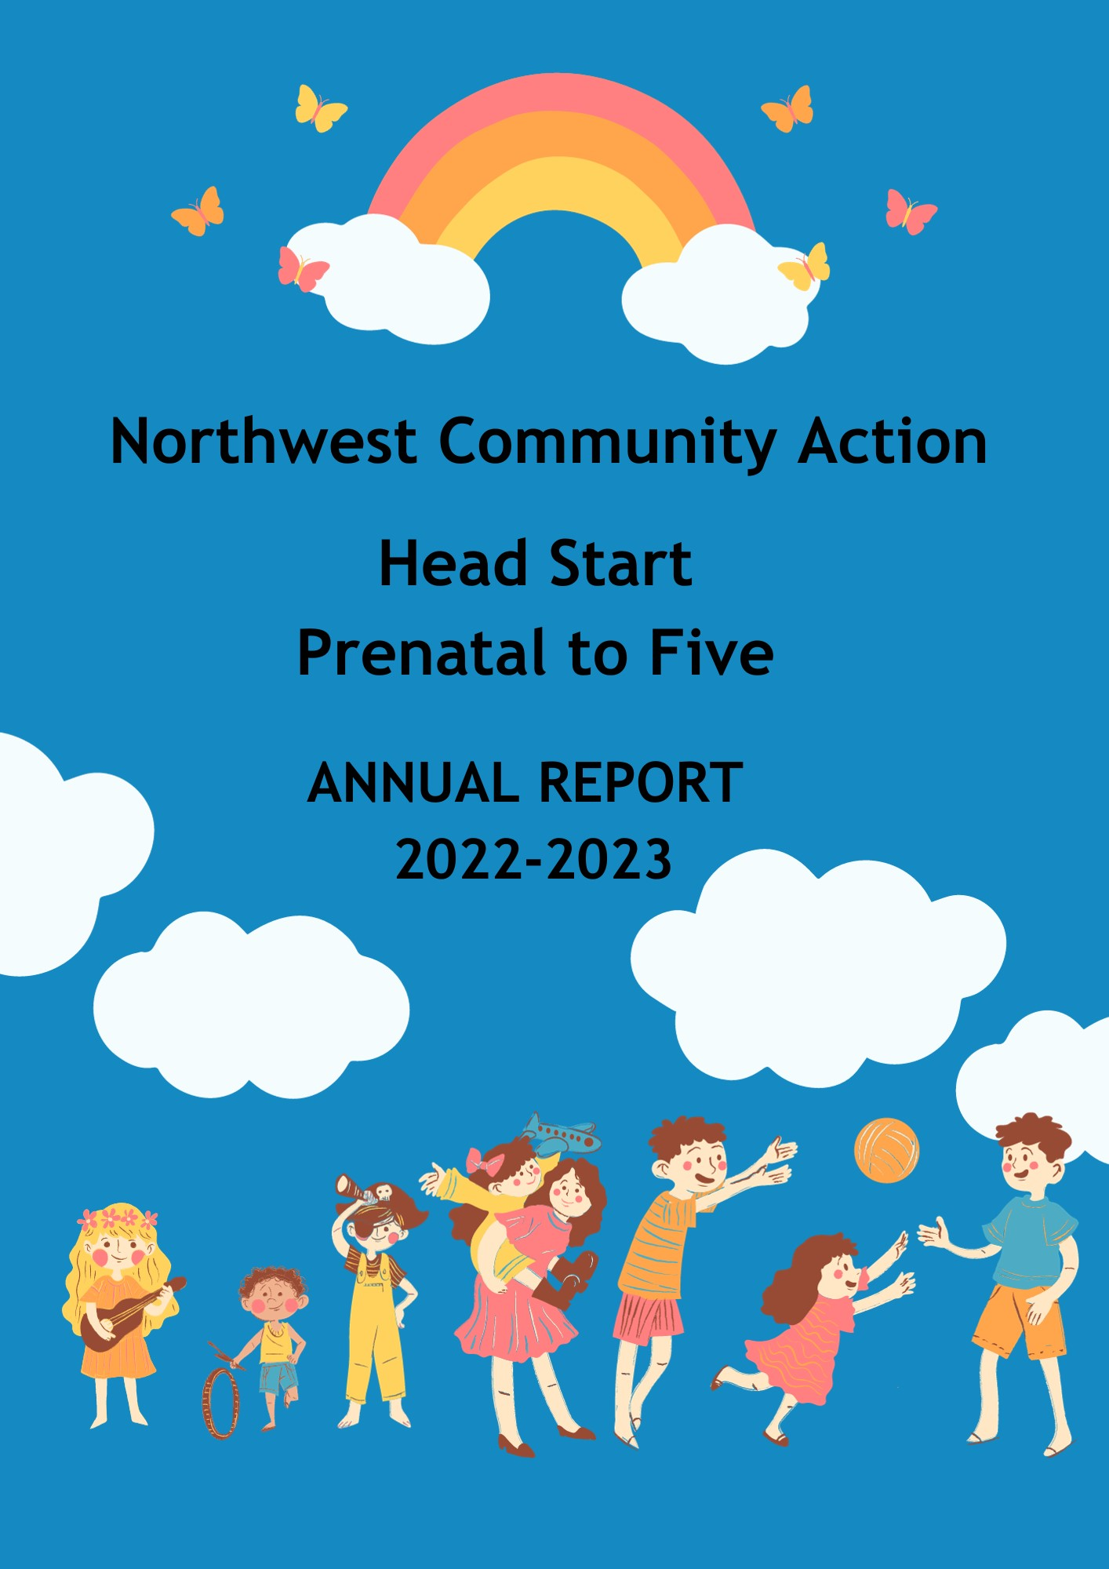
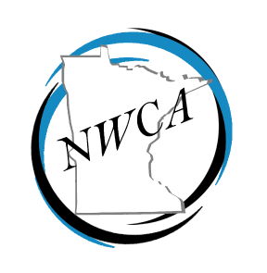
Our Mission is to stimulate a focusing of all available resources upon the goal of enabling area low-income families and individuals of all ages to attain skills, knowledge, and motivations, and secure the opportunities needed for them to become self-sufficient.
Annual Report 2022-2023
Head Start serving families prenatal to age five
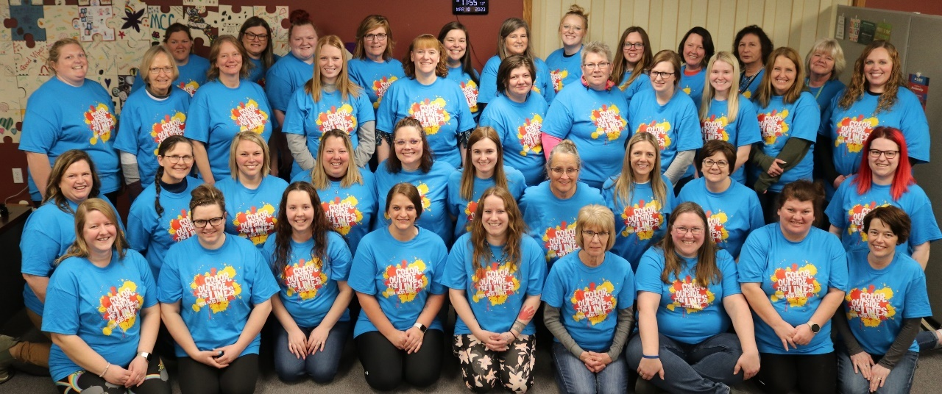

Northwest Community Action (NWCA) provides comprehensive Head Start services to 240 children and their families in our four-county service area: Lake of the Woods, Roseau, Marshall and Kittson county. A total of 155 families were served, including children with special needs and those needing individualized series. These services were provided in collaboration with their school districts. Head Start services include home visits and centers located in area schools providing nutritious breakfast, lunch and snacks. Additional services include medical screenings done with each county’s nursing service, oral health screenings, and follow-up work. Head Start may help with payment if the child is not covered by MA, MN Care, or other private insurance.
NWCA Head Start and Early Head Start promote parents as their child’s first, and most important teacher. Head Start parents have many opportunities to participate in educational activities in their individual service area. Parents participated in Policy Council both in person and virtually, attended local parent meetings, and worked with a teacher and their child on home visits. Additionally, conferences and home visits are held with each family throughout the year.
Five Year Program Goals
- Northwest Community Action, Inc. (NWCA) Head Start supports children and families to develop skills to enhance their nutrition, health and well-being.
- NWCA Head Start will support parents as lifetime learners and educators.
- Children enrolled in NWCA Head Start will gain skills needed to transition successfully to their next developmentally appropriate stage.

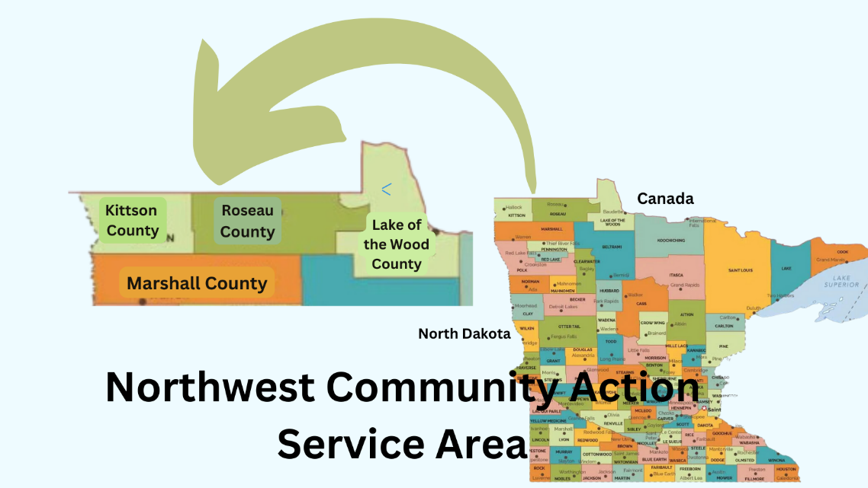
Northwest Community Action, Inc. continues to provide Head Start services to families in Marshall, Roseau, Kittson, and Lake of the Woods counties in the Northwestern corner of Minnesota. Our service area is bounded on the west by North Dakota and on the north by Manitoba and Ontario. This service area covers 6,500 square miles, in which over 32,000 people reside. The communities’ range in size from 50 to 2600 people. Our entire service area is designated Medically Underserved, and 2 of our classrooms are located in areas of less than 1,000 individuals, and 50 percent of the families are eligible due to income guidelines.
Policy Council
Parents are encouraged to be involved through parent committee meetings and Policy Council. This year’s Policy Council is made up of 9 Head Start and Early Head Start elected parents who lead and make decisions about our program. The Policy Council participates meetings with program management to evaluate, provide insight, encouragement and community engagement. Our Policy Council members are valuable members of our program and our gratitude for their volunteer time and talents are appreciated.

Who we serve

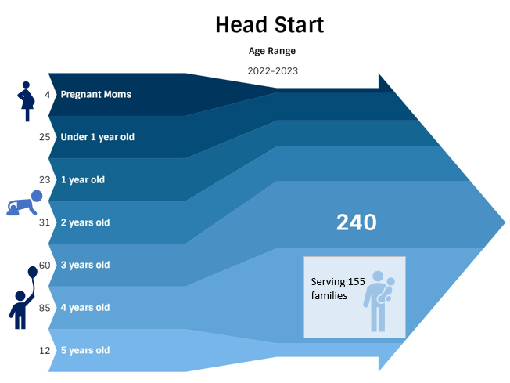

Fiscal
Head Start is funded with federal, and state dollars. Our recent financial audit was completed May 2023. NWCA has implemented the recommendations noted in our audit.

Funding

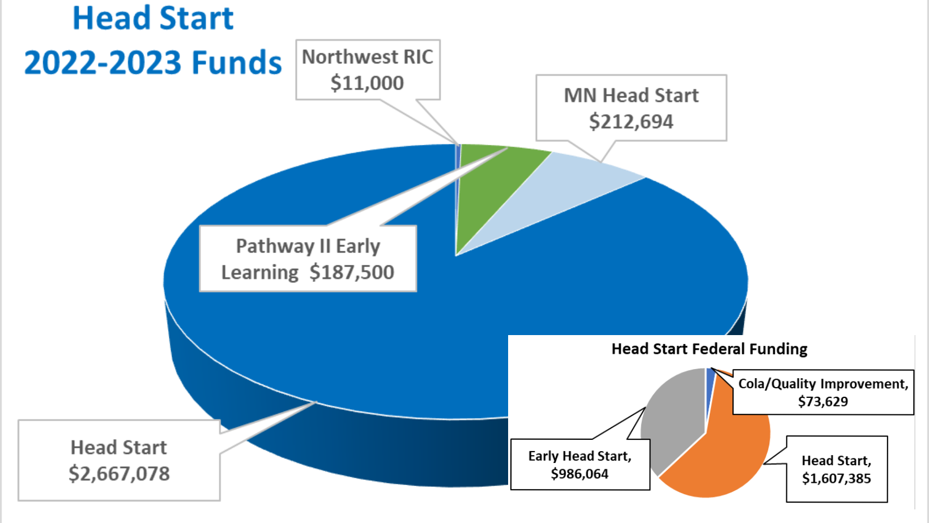

Expenditures
2022-2023 Head Start General Expenditures | Total
Personnel | $ 1,462,062.21
Fringe Benefits | $ 504,006.80
Travel/Travel-Out of Area/Vehicles | $ 139,742.95
Supplies | $ 220,571.09
Training | $ 142,217.12
Total | $ 2,568,306.47

Health
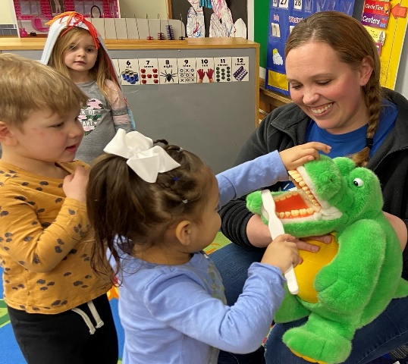
Our health-related services are well-received with staff and community professionals collaborating to complete health and developmental screenings. During the screenings, children are assessed on dental, vision and hearing as well as developmental screening test designed to identify young children who need further testing or who need help with academic skills. Children have received early identification of hearing, dental and vision needs.

School Readiness
NWCA Head Start promotes parents as their child’s first, and most important teacher. Head Start parents have many opportunities to participate in educational activities in their individual service area. Parents participated in Policy Council and with knowledge, attendance and participation growing with each meeting. Parent attend local parent meetings, work their teacher and their child on home visits. Additionally, 4 conferences are held with each family throughout the year. In Early Head Start, a weekly (46 total) home visits of 1.5 hours is done with each enrolled child and a parent. The Buddy Group get- together is held twice a month for families in each local area in which activities, education, and information is provided for the children and parents. Parent engagement is emphasized and literacy activities, budgeting education, mental health counseling, and crisis assistance are a few of the parent support services provided.
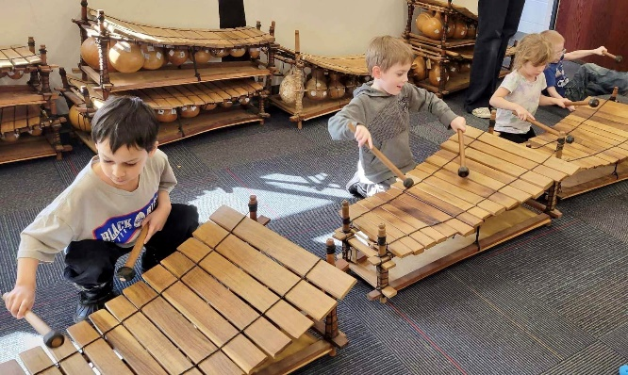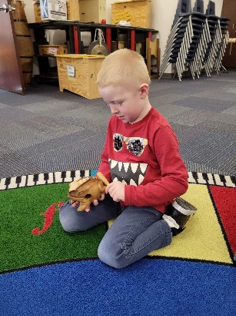

Early Head Start continued to utilize the Child Observation Record Advantage (COR) for outcome and growth tracking. The COR works well in monitoring infant and toddler development, and during the 2022-2023 program year there continued to be growth in all areas of development.

Early Head Start teachers utilize COR Advantage to provide a complete picture of each child’s development. COR Advantage allows teachers to observe children's development through play and naturally occurring activities.

We continued our involvement in a project to aggregate child outcome data statewide using the Teaching Strategies Gold (TSG). The intent of the program is to document child growth success as well as point to areas for improvement. The results will also help refine our efforts to optimize each child’s development and for transitions to kindergarten as well as individual teacher growth. During each school year, communications occur with kindergarten teachers in each school district to review expectations and discuss transition experiences. Developmental growth and/or concerns is shared as appropriate. Memorandums of Agreement that lay out transition activities and mutual school readiness goals are developed with each school district. Overarching goals and the developmental growth of Kindergarten-bound children are included below. There was growth from fall 2022 to spring 2023 in all assessment areas including; Social-Emotional, Gross Motor Fine Motor, Language, Cognitive, Literacy and in Math.
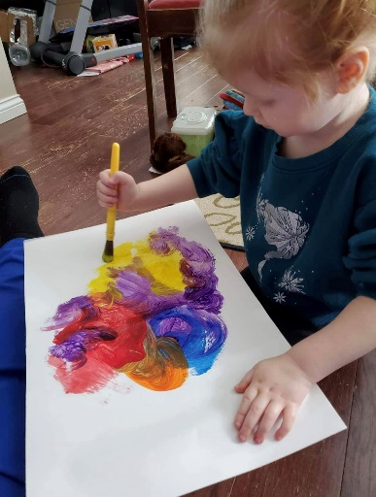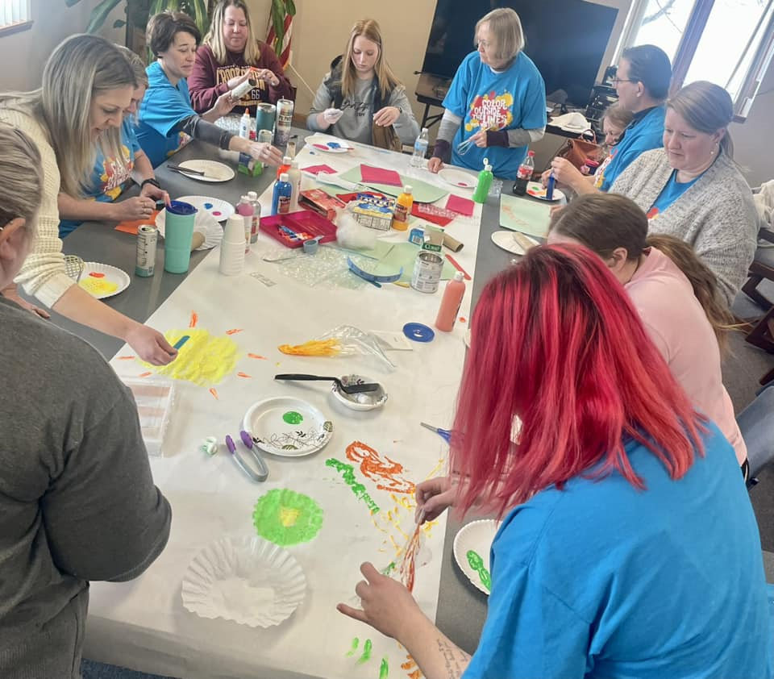

NWCA also participates with MHSA data collection and evaluation for School Readiness Outcomes. Participating with MHSA in this project provides information to showcase our efforts as well as identify areas of need. We are able to analyze our assessment results across the state. For example, if a classroom is showing higher or lower than average scores, we are able to compare across the state and/or do a deeper dive with our tools, classroom needs and documentation and act accordingly.
CLASS Observation and HOVRS provide teachers with constructive feedback; as well as areas to focus on for training. Requests for Conscious Discipline and Mental Health trainings are examples of requests that have resulted from observations.
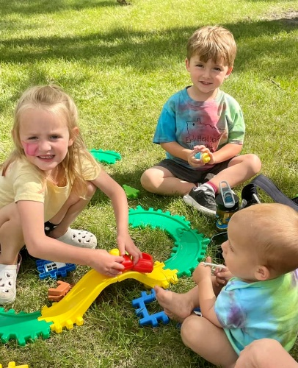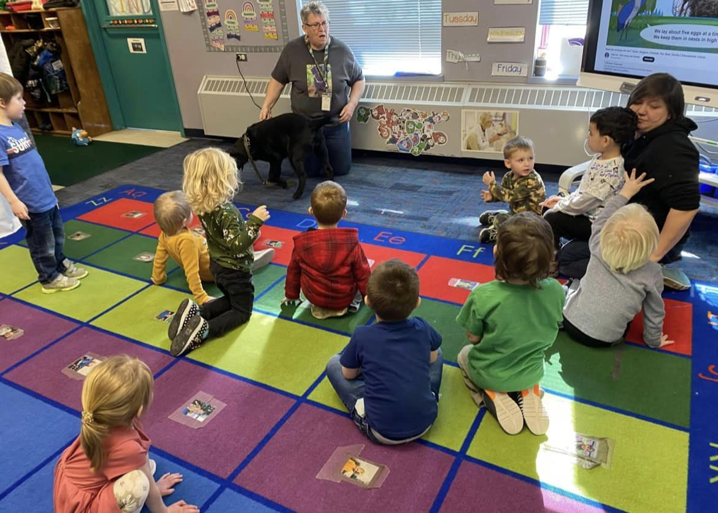

School Readiness Goals
School readiness is foundational across early childhood systems and programs.
- It means children are ready for school, families are ready to support their children's learning, and schools are ready for children.
- Head Start views school readiness as children possessing the skills, knowledge, and attitudes necessary for success in school and for later learning and life.
Physical Development and Health
1. Children will acquire and maintain a high level of physical health, including being up to date on physical and dental checkups and immunizations.
2. Children will demonstrate an increased ability to care for their own needs appropriately. They will become more independent and resourceful getting needs met.
3. Children will demonstrate increasing control of large muscles for movement, navigation and balance consistent with their chronological and developmental level.
4. Children will demonstrate increasing fine motor strength, coordination and agility for use in self-care, manipulation of materials and exploring their environment.
Social Emotional Development
1. Children will be able to manage feelings appropriately and self-regulate with regard to their emotions, attention span and behavior.
2. Children will demonstrate positive, appropriate social relationships with family members, peers and other significant adults.
Approaches to Learning
1. Children will demonstrate a positive approach to learning through persistence, attentiveness, engagement and curiosity.
2. Children will show an increasing ability to express themselves through sound, movement, visual media and role play.
Language and Literacy
1. Children will demonstrate increasing skills in comprehension and use of more complex and varying vocabulary.
2. Children will demonstrate increasing proficiency using language to communicate needs, wants and for self-expression.
Cognition and General Knowledge
1. Children will use math skills in everyday routines as appropriate for their developmental level with increasing competency in counting, comparing, relating and problem solving.
2. Children will engage in exploring their environment through observation, imitation, manipulation, and curiosity.
3. Children will demonstrate use of skills to solve problems, find multiple solutions and answer questions.

